3.30 周六| 德国法兰克福跳舞音乐界至关重要的幕后推手——Oliver Hafenbauer

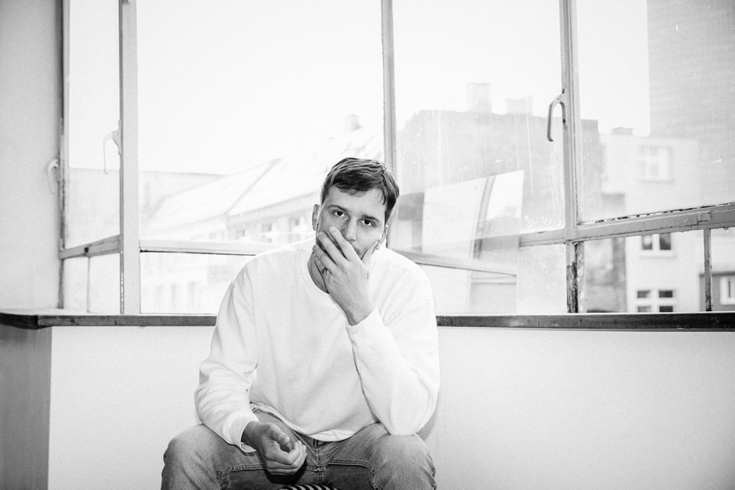
Oliver Hafenbauer

德国法兰克福著名俱乐部 Robert Johnson 的驻场DJ和音乐总监
成立并经营Robert Johnson内部音乐厂牌Live At Robert Johnson
创立了先锋个人厂牌Die Orake

3月30日这位举足轻重的幕后推手首次造访.TAG舞池！

（注：插入boiler room视频）

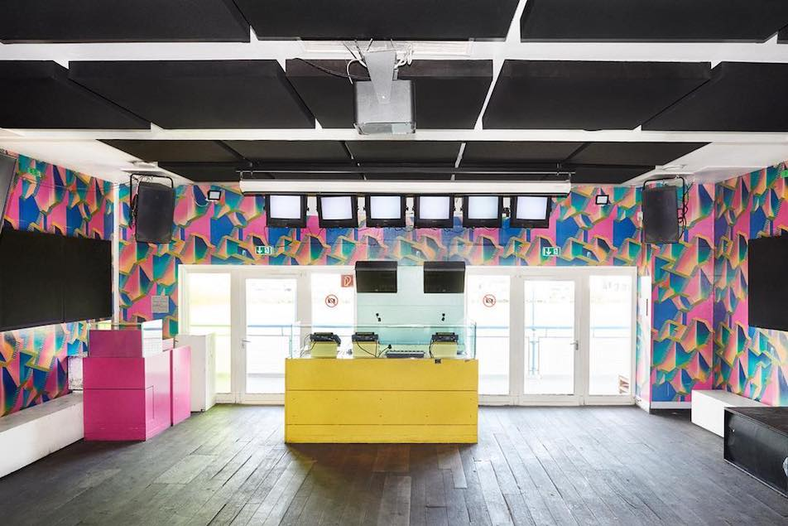
Robert Johnson俱乐部
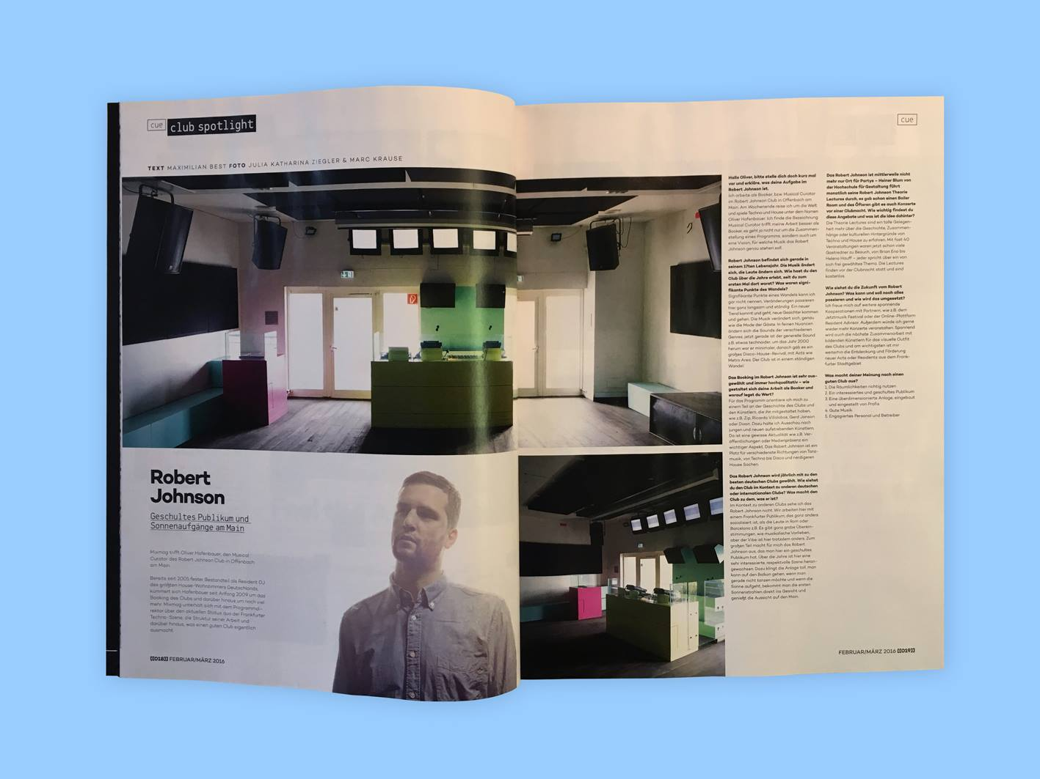
《Mixmag》—— Robert Johnson俱乐部

Robert Johnson是一个能容纳250人的中小型House/Techno 俱乐部，它成为了Dixon, Ricardo Villalobos, Gerd Janson, Hunee等著名DJ最爱表演的地方之一。英国二人组合Bicep曾在访问提到，他们的USB中有一个歌单文件夹已Robert Johnson命名，可见俱乐部在人们心中独特的地位。
Robert Johnson is the a highly-regarded dance venue in the region and is widely recognized as one of the premium clubs worldwide. Robert Johnson is a small and medium-sized House/Techno club that can accommodate up to 250 people. It is one of the favorite places for famous DJs such as Dixon, Ricardo Villalobos, Gerd Janson, Hunee and so on. The British duo Bicep mentioned in their interview that there is a song list in their USB that has been actually named after Robert Johnson, which shows that the club has a unique position in people's minds.

“Live At Robert Johnson” logo
（插入视频：Massimiliano Pagliara - Feel Live）

Oliver Hafenbauer于2005年加入Robert Johnson俱乐部，他成立并经营Robert Johnson内部音乐厂牌Live At Robert Johnson。该厂牌曾经发行了一系列备受喜爱的混音CD，而现今专注于发行高品质舞曲，艺人包括Massimiliano Pagliara和Portable et al等。
Oliver Hafenbauer joined Robert Johnson in 2005. He is the man who operates Robert Johnson's internal music label - Live At Robert Johnson. The label has released a series of well-received remix CDs, and today it focuses on high-quality dance music, including artists such as Massimiliano Pagliara and Portable et al.

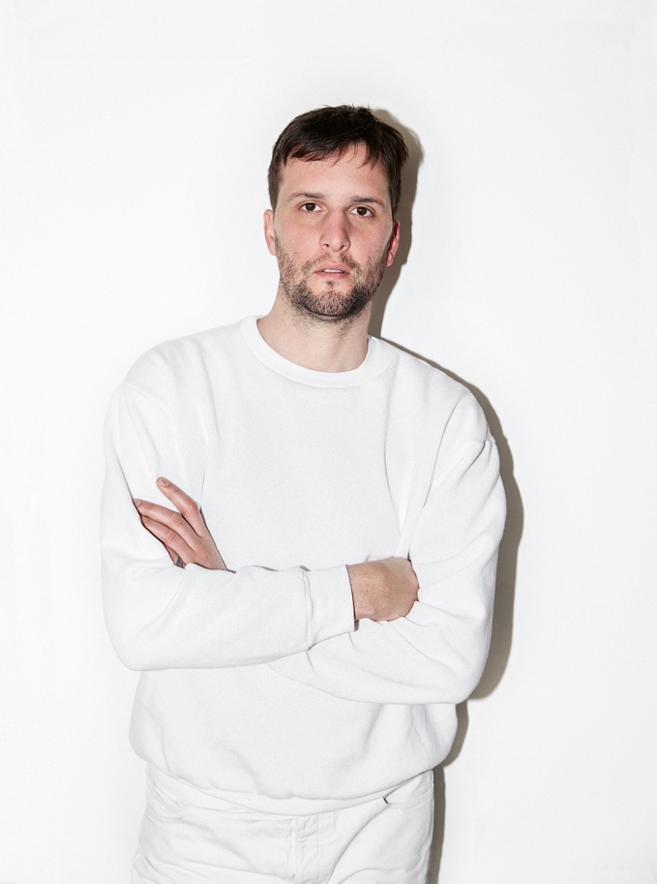

大多数制作人的成长途径通常是发行音乐，然后根据音乐的评价和销量而获得演出机会。然而Oliver Hafenbauer却打破常规，凭借着目前为止为Robert Johnson俱乐部所带来的贡献和功绩使他赢得了整座城市乃至整个德国地下音乐场景的尊重。同时伴随着这些认可和成就，他也争取到了一个可以充分释放他的才华与DJ技术的机会。
Most producers often grow their music by distributing music and then getting performance opportunities based on the reputation gained in their music. However, Oliver Hafenbauer has broken the rules. With the contributions and achievements, he has made in Robert Johnson, he has earned the respect of the entire city and the entire German underground music scene. Accompanied by these recognitions and achievements, he also won an opportunity to fully release his talent and DJ skills.

“die Orakel” Bandcamp logo
（插入视频：Roman Flügel - Verschiebung 1）

Oliver早期便开始接触英国顶尖厂牌Warp Records的音乐，深受影响。Aphex Twin、Board Of Canada、LFO、Auteche 等奠定了 IDM 理念的先锋音乐人皆出自Warp Records。为了更好的展示自己的音乐品味，2013年Oliver Hafenbauer开启了个人音乐厂牌Die Orkal。该厂牌以发行ambient、electronica、leftfield以及techno厂牌为主，发行过如Edward、Jaures和 Roman Flügel等艺人的作品。
Oliver came to contact with the top British label Warp Records early. The label is deeply rooted and influenced by Aphex Twin, Board Of Canada, LFO, Auteche, etc. which laid its IDM base. In order to better display his musical taste, in 2013 Oliver Hafenbauer started his label Die Orkal, which puts a focus on ambient, electronica, leftfield and techno. It has released music by artists like Edward, Jaures and Roman Flügel.

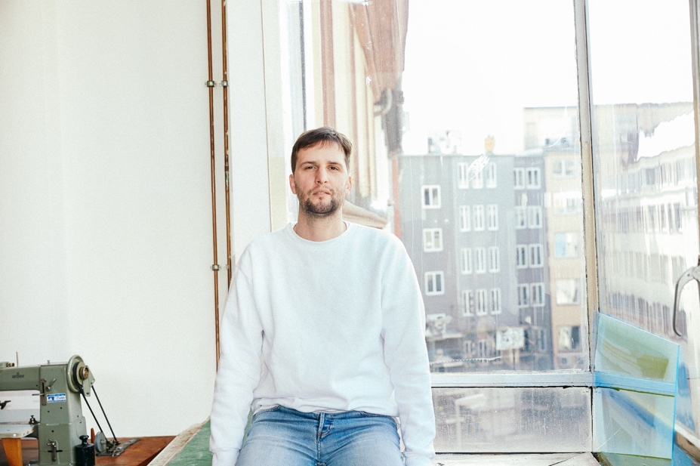

融合各种类型的音乐和情绪，从非洲头低调部落到Beatrice Dillon的舞蹈解构主义到Youandewan的时尚而深沉的电子house。Oliver Hafenbauer的混音是一种多面体的篝火，喜欢在纯粹舞蹈性和节奏性实验中迸发花火。
Combining all kinds of music and emotions, from the African tribal to Beatrice Dillon's deconstructed dance beats to Youandewan's stylish and deep electronic house, his sets are a layered bonfire that sparkles in the pure dance and rhythmic experiments.

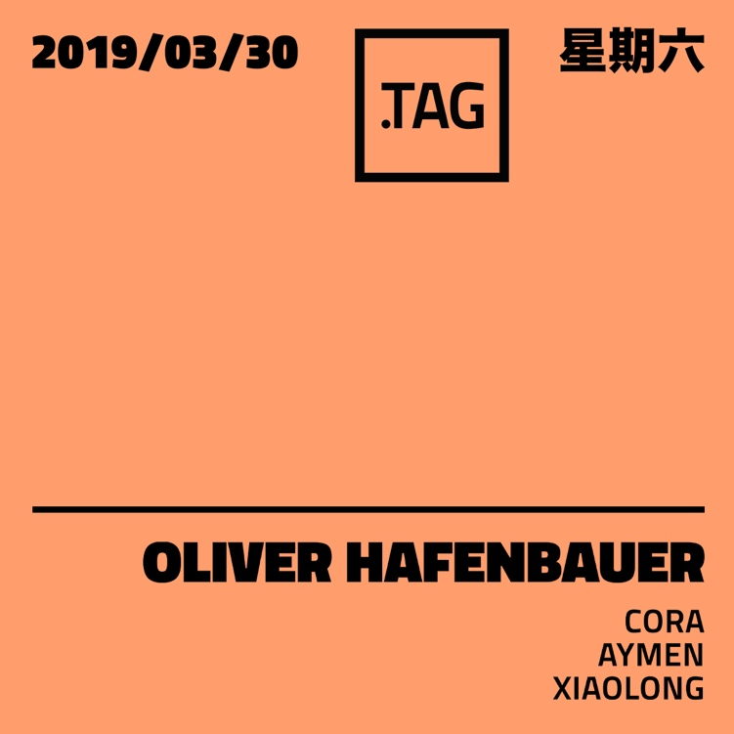

SUPPORT DJ:
XIAOLONG（放照片）

HIDDEN BAR DJs:
CORA（放照片）
AYMEN（放照片）

票价：早鸟50（20张）预售70 现场90

